Primary Literacy Programmes

Primary Literacy Programme – Reading (Key Stage 1) [PLP-R (KS1)]

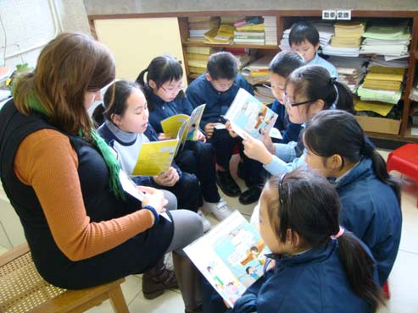“PLP-R (KS1) is a very effective programme in arousing students’ interest and confidence in reading. We are happy to see young students picking up English books in the library and some of them trying to sound out the words during independent reading. Thanks for the effort and support from the NET Section.”

Comments from a PLP-R (KS1) teacher

The English Language Curriculum Guide (Primary 1-6) (ELCG) published in 2004 and prepared by the Hong Kong Curriculum Development Council (CDC) recommended including a Reading Workshop component for 40% of the English lesson time in the school- based English Language curriculum. As a response to the above recommendation, the Primary Literacy Programme – Reading (Key Stage 1) [PLP-R (KS1)] was born.

The PLP-R (KS1) was developed by the Advisory Teaching Team (ATT) of the NET Section, Curriculum Development Institute (CDI), Education Bureau (EBD), Hong Kong Special Administrative Region (HKSAR). It harnessed the expertise and experience available in the Primary Native-speaking English Teacher (PNET) Scheme to support the development of a school’s Reading Workshop component as part of the school-based English Language programme. It provided direction and guidance for the teaching of literacy with a focus on reading as well as the tools necessary for the assessment of student needs and the knowledge of how they read. It supported setting up supportive language-rich whole-school and classroom environments and establishing classroom and resource management systems. It promoted the use of Storytelling, Reading Aloud, Shared Reading, Guided Reading and Independent Reading as teaching strategies for reading by teachers.

The two-year pilot PLP-R (KS1) began in September 2004 in 104 schools. The aims of the programme were two-fold. On the one hand, we wanted to enhance the reading proficiency of students through a sustainable literacy programme with a focus on reading. On the other hand, we supported English teachers with intensive professional development linked to the curriculum. We began with Key Stage 1 students in order to capitalise on the students’ enthusiasm and motivation when they began formal schooling and helped them develop positive learning habits and establish basic literacy skills at an early stage for future learning. The programme also provided teachers with direction and guidance for the teaching of literacy with a focus on reading as well as the tools necessary for the assessment of student needs and the knowledge of how they read.

The PLP-R (KS1) was implemented through the on-site support of Advisory Teachers (ATs). ATs made frequent visits to the participating schools to provide support in terms of centralised and school-based professional development workshops, classroom observations focusing on modelling and feedback for the teachers involved in the programme.

The PLP-R (KS1) was also fully supported with resources developed for teachers. The Teacher Manual explained how the programme should be implemented. The Units of Work, including the phonological awareness unit (Hear We Go), Home Reading Booklet, Matching Students to Book Levels Kit and Resource Packages provided support for its implementation. These programme materials were introduced to teachers through a series of centralised and school-based professional development workshops.

Impact of the PLP- R (KS1) on student learning

From 2004 to 2006, the Territory-wide Evaluation (TWE) on the PNET Scheme had been conducted by the University of Melbourne, the Open University of Hong Kong and the Hong Kong Institute of Education (Griffin, 2006). Part of the research focuses was on the PLP-R (KS1).

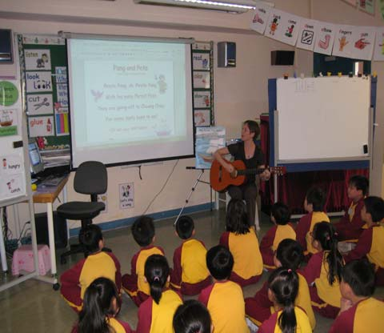The data from the TWE confirmed that “shared reading…led to greater growth in reading and writing over the three years.” This result was supported by another study conducted by Elley in 1992 in Singapore “which has adopted shared reading nationally…where children learning to read in their second language produced mean scores that were well above the international averages” (Smith and Elley, 1997). The same findings were mirrored by research in Sri Lanka reported by Elley and Foster in
1996, in South African by Le Roux and Schollar in 1996 underprivileged schools and in Brunei Darrusallam by Ng and Larking in
1994 (Smith and Elley, 1997).

The above research showed that students were gaining skills in word recognition, oral language, reading and inferential comprehension, and vocabulary at an increased rate if they were “led to interact with them (the books) actively, as in shared reading…” (Elley and Foster, 1996 in Smith and Elley, 1997). The Territory-wide Evaluation of the PNET Scheme made comparison of gains in students’ reading proficiency in PLP-R (KS1) versus non- PLP-R schools. The results indicated positive trends for students in PLP-R (KS1) schools in terms of reading and writing proficiency. Observations also indicated changes to classroom practices for schools participating in the programme.

This confirms not only that shared reading is effective in second language acquisition, but also that shared reading has been effective in Hong Kong context in the PLP-R (KS1) over the past three years.

As a testament to the success of the pilot, an invitation was issued to the non-PLP-R schools to be part of the PLP-R (KS1) in 2006 and 67 schools were accepted as part of the new cohort of PLP-R (KS1) schools. To date, 1,910 primary teachers have been trained and the Programme has involved a total of 40,267 students.

Primary Literacy Programme – Reading and Writing (Key Stage 1) [PLP-R/W (KS1)]

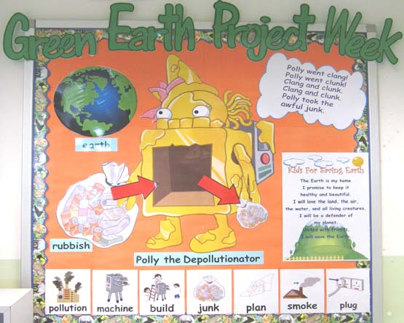The NET Section decided to refine and review the PLP-R (KS1) to incorporate some of the above suggestions through developing the Primary Literacy Programme – Reading and Writing (Key Stage 1) [PLP-R/W (KS1)] in 2007. It was decided to adopt a holistic approach incorporating the four skills to the primary literacy programme, but still have an emphasis on reading and writing. The decision was made not only to continue with shared reading as the main teaching strategy, but also include the other teaching strategies.

The ELCG was the basis for the direction in the teaching of writing skills. This facilitated the use of shared writing as the main teaching strategy, but underpinning this was the process of writing, which was explicitly introduced.

The TWE report also indicated an “over reliance on textbooks” in the English classroom. During the implementation of the PLP-R (KS1), it was clear that integration was the biggest problem. Teachers were not able to integrate the General English (GE) lessons which focused mainly on the use of textbook materials, with the PLP-R (KS1) lessons. The pilot PLP-R/W (KS1) allows for integration between the PLP-R/W (KS1) and the textbook resources. For this reason the NET Section produced the big and small books and facilitated the integration. These books have also been written with the local context in mind. Similar to the PLP-R (KS1), intensive support is given through professional development workshops, followed by in-class support through weekly visits by the ATs and the development of a range of materials and resources.
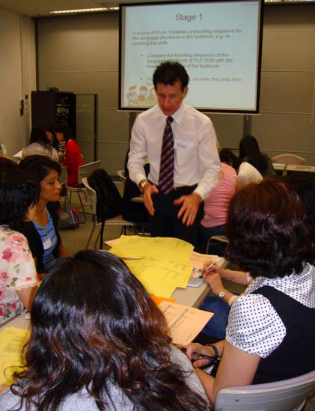

“Students can write more now. They are no longer scared of writing. All the students want to try to participate…willing to take risks.”

Observations from a
PLP-R/W (KS1) teacher

The PLP-R/W (KS1) is currently being implemented in a total of 170 schools involving
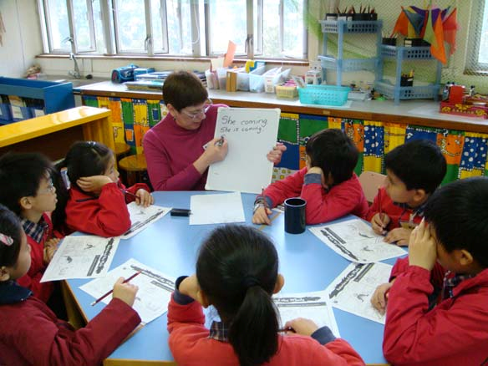1,402 teachers and 33,642 students.

Impact of the Literacy Programmes on teachers

Both PLP-R (KS1) and PLP-R/W (KS1) initiated by the NET Section place heavy emphasis on professional development and aim at equipping teachers with a wider repertoire of teaching strategies. As effective classroom practises are not sustainable unless teachers understand the rationale behind the programme design, collecting teachers’ feedback on the implementation of PLP-R (KS1) and PLP-R/W (KS1) is necessary.

As part of the on-going evaluation of both PLP-R (KS1) and PLP-R/W (KS1), teachers have been asked for their input through questionnaires and focus group discussions. When asked about the sustainability of the programmes, over 90% of teachers currently involved in PLP-R (KS1) and PLP-R/W (KS1) responded that they would maintain the programmes even if all support was removed. This is a reflection of the effectiveness of the programmes and the value the schools place on the two initiatives.

“The PLP-R/W (KS1) is a well-worth experience for students” “The presenters were patient, discussing in detail and giving practical demonstration of one of the sessions.”

Comments from PLP-R/W (KS1) teachers

